The Electromagnetic Spectrum

Go to the NASA website http://science.hq.nasa.gov/kids/imagers/ems/index.html

- Fill in the missing labels on the electromagnetic spectrum.
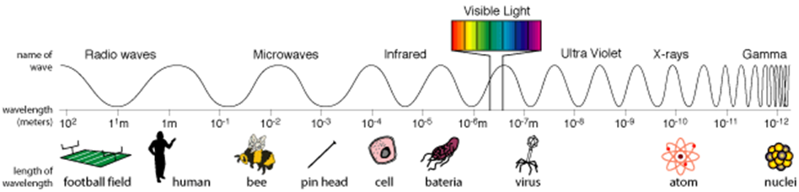

Click on ‘What are electromagnetic waves?’

- In your own words, describe what electromagnetic waves are.

- What did James Clerk Maxwell and Heinrich Hertz study?

Click on ‘Different kinds of electromagnetic waves have different wavelengths.’

- In your own words, describe what is meant by wavelength. Include a diagram as part of your description.

Click on ‘Radio waves’

- Radio waves have the longest/shortest wavelengths in the electromagnetic spectrum.

- What length can radio waves be?

- Give three uses for radio waves.

- Radio telescopes are used to study planets, comets, stars and galaxies.
  - What are astronomers able to learn by studying the radio waves from these objects?

  - What is an advantage of radio astronomy?

Click on ‘Next Shorter Wavelength’ (Microwaves)

- Give the range of lengths of microwaves.

- What are longer microwaves used for?

- Why are microwaves good for transmitting information from one place to another?

- What are shorter microwaves used for?

Click on ‘Next Shorter Wavelength’ (Infrared)

- Give the approximate sizes of infrared waves?

- What are far infrared waves and how do we experience them?

- What are near infrared waves and what do we use them for?

Click on ‘Next Shorter Wavelength’ (Visible)

- Each colour of visible light has a different wavelength.
  - Which colour has the shortest wavelength?
  - Which colour of light has the longest wavelength?
  - What do all the colours of light make when they are seen together?

- Name two sources of visible light.

Click on ‘Next Shorter Wavelength’ (Ultraviolet)

- What type of organisms can see ultraviolet light?

- How do scientists classify UV light?

- What does the Earth’s atmosphere do to UV light and why have scientists developed a UV index?

Click on ‘Next Shorter Wavelength’ (X-rays)

- What happens to the energy of light as its wavelength decreases?

- Why do we normally talk about x-rays in terms of energy rather than wavelength?

- X-rays were first discovered by Wilhelm Conrad Roentgen in 1895. Describe how he discovered them and how he showed his findings to the public.

- Describe how x-ray images are taken of parts of your body.

Click on ‘Next Shorter Wavelength’ (Gamma rays)

- Describe the wavelength and energy of gamma rays.

- How are gamma rays dangerous to living organisms?

- How do humans use gamma rays?

- Where and how are gamma rays produced?

